Commissioning Procedure for FMC IP ATN910C-G Integration

(version 1.6)

Revision number: | 1.7 | Approvers:
Date: | 25/08/2023 | Authors: | F. Vismara
Pages: | 11 | Reviewers: | P. Pelosato L.Angarella
Code:
Protocol:

Rev. | Data | NOTE | Author
1.0 | 02/07/2020 | First Draft | F. Vismara
1.1 | 16/07/2020 | Correction on number of license items for 10G ports | P. Pelosato
1.2 | 25/09/2020 | Add. Sec. 6.4 | F. Vismara
1.3 | 05/10/2021 | Updated to V3R7C00SPC100 | F. Vismara
1.4 | 05/08/2022 | Updated to V8R21C00SPC100 | F. Vismara
1.5 | 20/09/2022 | Added new BOM codes for SFP.1G and 10G. (pag. 3, 7, 9) | F. Vismara
1.6 | 06/02/2023 | Added new BOM codes for SFP.1G and 10G (pag. 3, 7, 9)  Patch upgraded to V800R021SPH180 | L. Angarella
1.7 | 25/08/2023 | Patch upgraded to V800R021HP2201 | F. Vismara

Table of contents
Contents
Commissioning Procedure for FMC IP ATN910C-G Integration 1
1 Materials Needed 3
2 Device Photo 3
3 Software & License Check 4
4 Equipment Health Check 4
4.1 Disk Space Check 4
4.2 Memory and CPU Usage 5
4.3 Check Temperature 5
4.4 Check Fans 5
5 Power Check 5
5.1 Power Redundancy Check 5
5.2 Voltage Check 5
6 Ports Test 5
6.1 Modules Check 7
6.2 BOM Check 7
6.3 Port Bandwidth Check 8
6.4 Port License Resource Distribution Check 8
7 Collect Device Information 8
8 Configuration Check 9
9 Alarms Check 9
9.1 Alarm Active / All 10
9.2 Alarm History 10
10 GPS Signal Check 10
11 Non Standalone Checks 11
11.1 LLDP Neighbor Check and Interface Check 11

Materials Needed
In order to complete the Commissioning Procedure we need the following tool:

4 Optical transceiver,SFP+,1310nm,10Gb/s,-8.2~0.5dBm,-12.6dBm,LC,SM,10km PN: 34060742 / 34060742-00x / 34060599
8 Optical transceiver,eSFP,1310nm,1.25Gb/s,-9~-3dBm,-20dBm,LC,Single Mode,10km PN: 34060473 / 34062523
- Optical Transceiver,eSFP,850nm,2.125Gb/s(Multirate),-9.5~-2.5dBm,-17dBm,LC,MM,0.5km (opt., transito su DWDM) PN: 34060286
- Optical Transceiver,eSFP,1471nm,100M~2.67Gbps,5dBm,0dBm,-28dBm,LC,80Km (optional, fibra like passive) PN: 34060483
- Optical Transceiver,eSFP,1571nm,100M~2.67Gbps,5dBm,0dBm,-28dBm,LC,80Km (optional, fibra like passive - fibra like passiva - sostituzione 34060483) PN: 34060476
- Optical Transceiver,SFP+,1550nm,9.953~10.3125Gb/s,0~4dBm,-24dBm,LC,SM,80km (optional, fibre miste o lunghe >8km) PN: 34060672 / 34060672-001
- Optical Transceiver, SFP+,1471nm,9.95~11.1Gb/s,0dBm,4dBm,-23dBm,LC,SM,70km (optional, fibra like passiva) PN: 34060687

1 Fiber Loop Tool OR LC – LC fiber cable
1 Console Cable for ATN + USB adapter and drivers
1 DATA CARD
1 Optical Power Meter
1 Multimeter
1 Screwdriver (Phillips type)

Aprire il file “VDF Delivery Procedure for FMC ATN910C-G” e seguire fino al termine, prima di procedere al prossimo paragrafo.

Device Photo
At the end of the Commissioning procedure and before leaving the operations site, take a clear photo of the commissioned device, frontal view.

Software & License Check
To ensure that right version is installed on the ATN, run the command display version, followed by display license and collect the outputs.
The OS version MUST be V800R021C00SPC100 . The PATCH MUST be HP2201 .

Check the license items and quantity as in the table below:

MODELe | OS | PATCH | LICENSE ITEMS | Filename
ATN 910C-G | V800R021C00SPC100 | HP2201 | REFER TO TABLE BELOW | ATN910C-910D_V800R021C00SPC100.cc  ATN910C-ABDFGHS-V800R021HP2201-C00SPC100.PAT

Part Model | Part Number | Description
ANGS00SRV610 | 88035JNU | ATN 910C SRv6 Function License
ANGS0AVAND00 | 88035JNK | ATN 910C Service Advanced Function License
ANGS0DTECT00 | 88035JNJ | ATN 910C OAM Enhanced Function License
ANGS0TMSYN01 | 88035LWQ | ATN 910C Time Advanced Synchronization Function License
LANG2XGEPAY01 | 82601038 | ATN 910C 2*10GE Port RTU
LANG4GEPAYG02 | 82601039 | ATN 910C Any 4GE/FE Port RTU

Base software includes 2x10G + 8x 1G ports enabled
Note: quantity of LANG2XGEPAY01 can be 0 (type A) or 1 (type B – total 4x 10G ports enabled)

Equipment Health Check

Disk Space Check
Check and collect output of dir /all-filesystems command to verify that only the required files are saved on cfcard and to show how much memory is available.

Memory and CPU Usage
Collect the output of display health command to verify the CPU and memory status.

Check Temperature
Collect the output of display temperature command to verify the temperature “Status” is “NORMAL” for all the components.

Check Fans
Collect the output of display fan command to verify that the fan modules are Present and Registered and fan speed is below 100%.

Power Check

Power Redundancy Check
Enter the commands display device and display power.

Voltage Check
Enter the command display voltage and verify that no power supply anomalies are present.
Ensure the all entries for STATUS are NORMAL.

Ports Test
It is mandatory to conduct a loop test of ALL the device SFP ports, both 10 and 1 Gb/s.
The picture below displays the position of the ports that must be tested.
BLUE – use 10Gb/s transceiver (if available) – port 0/2/0 to 0/2/3
RED – use 1GB/s transceiver – port 0/2/16 to 0/2/23
GREEN – use 1GB/s transceiver # - THIS PORT 0/2/27 IS RESERVED FOR ATOM GPS MODULE

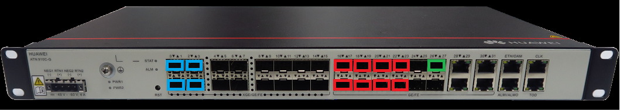

In absence of a dedicated tool for looping test, it is sufficient to connect a single LC – LC fiber to a transceiver (see photo below) and plug it into a SFP port of the corresponding type.

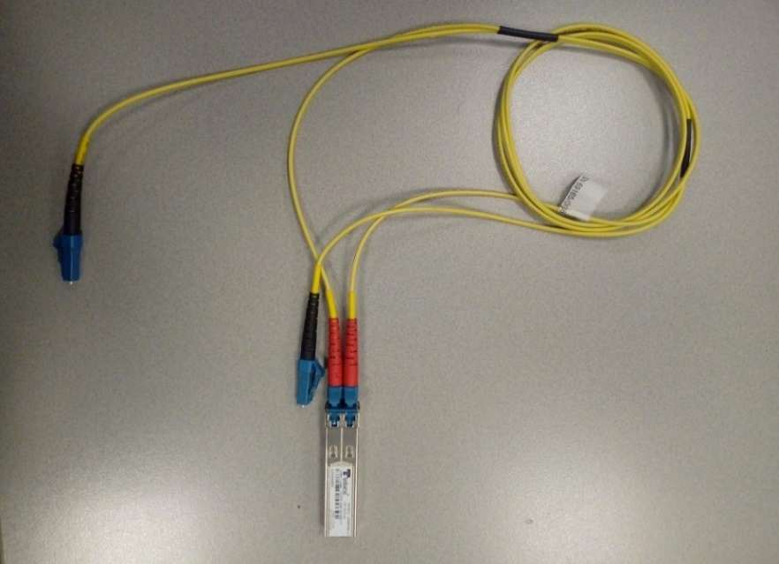

To speed up the procedure, it is suggested to connect a second transceiver of the same type to the other fiber in order to loop two ports at the same time (see photo below).
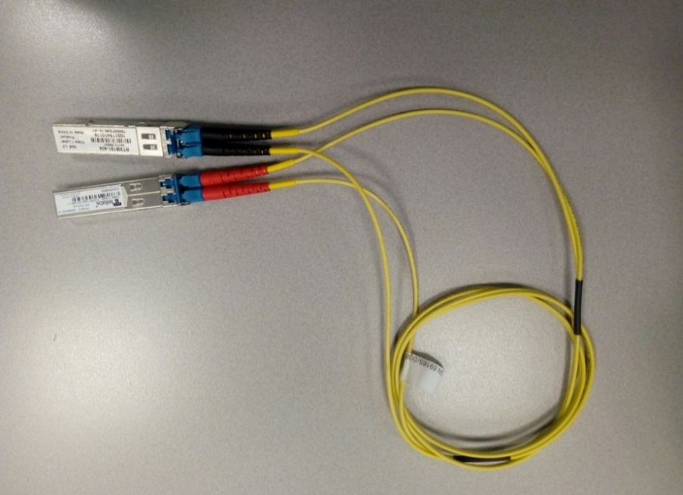

6.1 Modules Check
Enter sys and port-group group-member G0/2/1 to G0/2/27, then undo shutdown and commit.

Finally, run the following command for as many time as necessary: display optical-module brief
Check if all the looped ports have good TX-RX values.

>>> Once finished, issue commands
rollback configuration last 1
y
of the device, then proceed with step 6

IMPORTANT - The following tests MUST be performed ONLY with optical modules that are part of the installation kit and will be left on the device.

6.2 BOM Check
10Gb Mod. Item MUST BE = 34060742 / 34060742-00x / 34060599 / 34060672 / 34060672-001 / 34060687
1Gb Mod. MUST BE = 34060473 / 34060476 / 34060483 / 34062523 / 34060286

With ALL available modules inserted, copy and paste the following lines:
dis elabel | in Item=3406
dis elabel | in Item=3406 | ex 0742|0742-00|0599|0672|0672-001|0687|0473|0476|0483|2523|0286 | count

If “Total lines: ” number is greater than 0,
INFORM THE REMOTE SUPPORT IMMEDIATELY!

6.3 Port Bandwidth Check
Verify that all license-enabled ports have been activated with the command “display interface brief”.
Ports not enabled will be displayed with (100M) :

GigabitEthernet0/2/x (100M)

All the ports connected must be enabled. If not enabled, configuration must be corrected with the commands

system-view
license
active port-basic slot 2 port <port-list>
commit

6.4 Port License Resource Distribution Check
Enter the command display license resource usage port-basic all and verify that under column “Active Status” none of the ports has a reported status of Allocated. ALL PORTS MUST BE IN ACTIVATED OR NO ALLOCATED STATUS.
IF NOT, CONTANCT THE REMOTE SUPPORT FOR INSTRUCTIONS.

Collect Device Information
Collect all the information about ATN hardware using the commands:
display elabel brief
display elabel
display elabel backplane
display elabel optical-module brief

Ensure the “BarCode” of the GPS 905M-A is the following: 034CGQXXXXXXXXXX

Ensure the “Item” codes match the following:
- slot 2 > 02352YTQ or 02352YTQ-003
- SFP SM 10Gb (slot 5 and 6) > 34060742 / 34060742-00x / 34060599 / 34060672 / 34060672-001 / 34060687
- SFP SM 1Gb (slot 1 and 2) > 34060473 / 34060476 / 34060483 / 34062523 / 34060286

Configuration Check
> ATTENTION! IF CONGURATION FILE IS UNAVAILABLE AT THE TIME OF COMMISSIONING, SKIP THIS STEP!

Ensure that the configuration was successfully applied, by entering command:

display configuration recover-result

The output must be (second line from top):
The number of failed commands is 0.

Alarms Check
Per pulire eventuali allarmi residui, si consiglia di fare copia e incolla dei comandi sottostanti prima di procedere:

clear alarm all no-trap
y
sys
alarm
clear alarm history all
clear alarm active all
q
q

Alarm Active / All
Collect display alarm all and display alarm active outputs commands to ensure that device is working and running without any problem.
The ATN must complete the “Commissioning Procedure” without any significant alarm.

Alarm History
Run command display alarm history to check if there are some recursive alarm.
Especially check if there are some alarms related to “excessive frequency offset”.

GPS Signal Check
First, ensure that the interfaces is up and configured by entering:
dis curr | sec in interface GigabitEthernet0/2/27
[…]
#
interface GigabitEthernet0/2/27
description SFP GNSS
undo shutdown
undo dcn
ptp notslave disable
ptp enable
smart-clock ptp priority2 127
smart-clock ptp domain 24

> ATTENTION – ONLY IF all the lines marked in blue are present, proceed to complete the check.

display smart-clock interface G0/2/27

The expected output must include (lines 4 and 5 from top):
Time lock success :yes
Freq lock success :yes

Non Standalone Checks

LLDP Neighbor Check and Interface Check

- Collect the output of display lldp neighbor brief command to check the connectivity of the device with upstream node.

- Collect the output of display interface GigabitEthernet0/2/0 with fiber cable connected to Optix/optical panel.

> END of Procedure – Remove serial cable <

